

# Intelligent Systems



**Assignment 2. Problem-Solving Agents**

This activity consists in solving a problem by formulating it as a simple state problem to be solved by a problem-solving agent (PSA), then designing and implementing several heuristic functions to solve it by using selected search methods.

**Broken Calculator**

*Broken Calculator* is a puzzle game that requires that you help Eric to calculate some numbers using his smashed calculator. Most of the keys of the calculator have fallen off, but some of it still works and you can use them to find a sequence of key presses to compute a group of numbers.

The game, that you can find and play in the link [http://www.mathsisfun.com/games/broken-](http://www.mathsisfun.com/games/broken-calculator.html) [calculator.html,](http://www.mathsisfun.com/games/broken-calculator.html) consist of several levels that show the calculator with different keys and different groups of numbers to compute within a time limit.

Examples of the levels are:

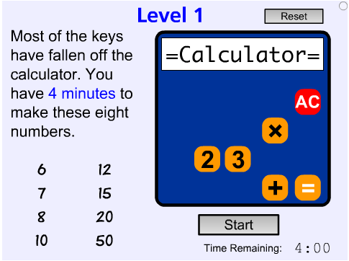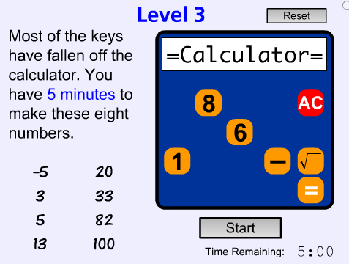

Image taken from Math is Fun (20016) Broken Calculator Game. Recovered from<http://www.mathsisfun.com/games/broken>-calculator.html

For this activity you must do the following:

1. Analyze the problem to determine the information that is relevant to its formulation as a PSA. Choose a way to represent states in the programming language (**Python**). Use this form to describe the initial state for at least one level. The time limit of the original game is not relevant for this assignment.
2. Implement the required code in the programming language to be able to solve the selected level using the blind search methods already programmed and included in the Python AIMA code. You must properly display the states’ information. Your code must work correctly when being used by the functions that implement the respective search methods.
3. Design two non-trivial heuristic functions, where at least one is admissible. Explain the intuition behind the heuristics and prove that the admissible one really is admissible.
4. Implement both heuristics in the programming language to be able to solve the challenges using the heuristic search methods also included in the Python AIMA code.
5. Execute the blind and heuristic search methods (with the 2 heuristics) to solve the selected level for 3 numbers that can be calculated and 3 numbers that cannot, and show the solutions found by each method.
6. Add observations and conclusions about your experience by programming and using each algorithm to find the solutions: Could they solve all or some problems? How efficient were they? Was it difficult to program the PSA? What cost you the most effort? Also, which algorithm seems to be the best for the selected problems? Which happened to be the best heuristic? And which methods found the best solutions?
7. PSA Formulation

Configuration State: State, es un numero que representa el valor actual que tiene el nodo, después de realizar las acciones anteriores a este nodo, Operadores son las acciones que podrán realizarse, Numeros iniciales son los números con los que puedes hacer las diferentes combinaciones de estados. Goal represent the number that the program must find.

Initial State = Es un numero, por lo general Cer0 (0), que representa el valor inicial con el que se calcularán los siguientes estados.

Actions: [MINUS(-), DIVIDE(/), PRODUCT(*), CONCATENATE(&), PLUS(+), ALL CLEAR(AC)]

Transition Model: Cada acción puede aumentar o disminuir el resultado

State- Space (Initial State and possible actions)

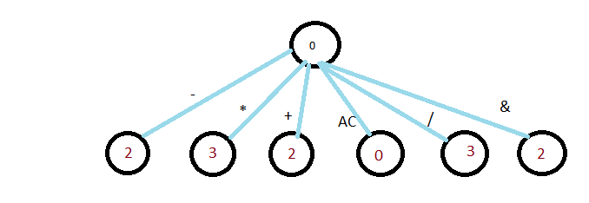

Represent the first state and the possible actions for state.

Goal state = Find the number represent in the goal value in the node state.

Path cost = Diferencia absoluta entre el estado anterior(n) y el nodo hijo (n+1)

Initial states:

The initial state is represent by a number (for common is zero)

The way to calculate a new state is a follow:

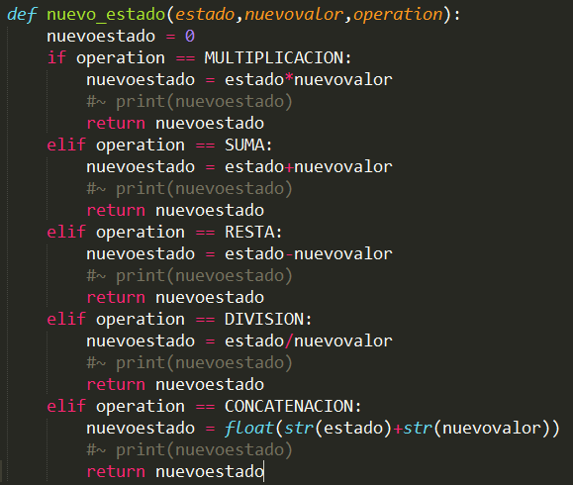

El estado nuevo es definido por la operacion que se hace sobre el estado anterior y un valor para obtener un nuevo estado

EVALUATION CRITERIA:

The weights assigned to the activities for the evaluation of this activity are:

* PSA formulation: 20%
* Description of initial states: 10%
* Code for blind search: 20%
* Design of heuristic functions: 20%
* Code of heuristic functions: 10%
* Solution of the problems: 10%
* Observations and conclusions: 10% Take into account the following:
* The formulation of the PSA must be complete and adequate for its implementation in the programming language.
* The initial state descriptions for the problems must be in the programming language.
* The blind search code must allow all blind search methods to run correctly, even if some cannot find the solution.
* It will be verified that the two heuristic functions make sense and that at least one is admissible.
* Heuristic search methods must be run correctly and find solutions.
* They should show the sequence of actions and the states of the problem after each action for each solution found by each of the methods that can solve them.
* Try to be concise in answering questions, but at the same time be clear and answer them all.